DAY 23: Ticketing System
- What is ticketing system
A ticketing system is an IT service management tool designed to facilitate, organize and streamline the process of tracking, managing, and resolving service requests or incidents.
In essence, it acts as a centralized hub that collects issues, queries, or requests from end-users or clients and tracks those through resolution. [1]
=> Ticket = Alert/Complaint of customer/Troubleshooting/Any Request…
Ticketing system satisfies A.A.A model
- How does ticketing system work
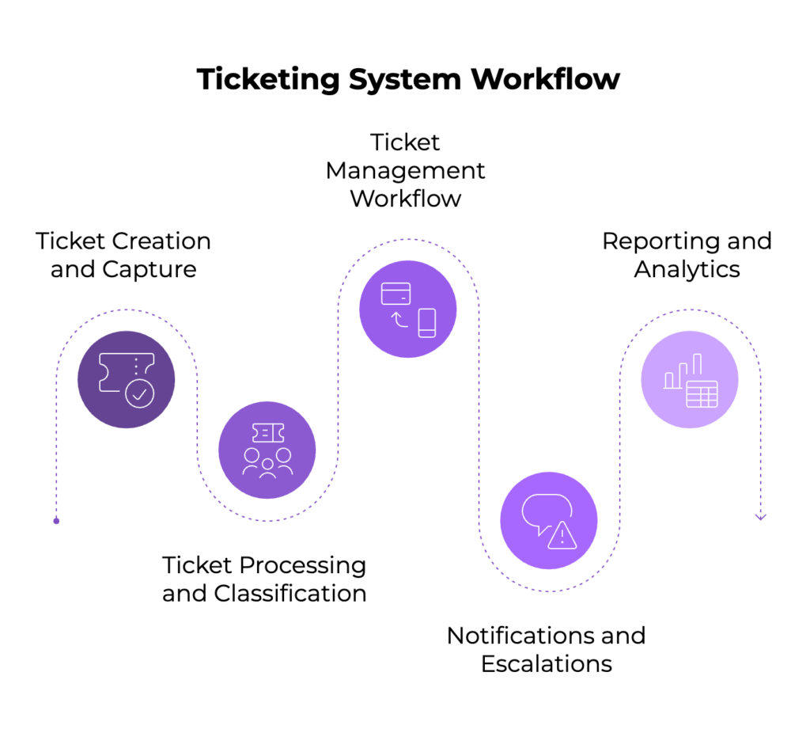
Figure 1: Ticketing System Workflow
2.1. Ticket Creation and Capture
Tickets can be generated from multiple input channels:
- Web portals where users submit issues directly.
- Email integrations, which automatically convert incoming support emails to ticket entries using configurable email readers and mapping functions.
- Phone calls logged by support agents.
- Automated system alerts for IT infrastructure.
2.2. Ticket Processing and Classification
Each ticket is associated with organizational units such as machines, groups, or departments. Using pre-defined policies:
- Assignee Policy: Automatically assigns tickets to specific team members based on ticket metadata combinations (e.g., priority + category).
- Due Date Policy: Assigns due dates to tickets based on urgency and service levels, ensuring SLAs (Service Level Agreements) are respected.
2.3. Ticket Management Workflow
Support staff use these centralized interfaces:
- View Summary: View all tickets in a list, highlight new or unread tickets, apply filters, and search.
- Create / View: Add or modify tickets and their notes, attach files, and update ticket status.
- Delete / Archive: Maintain database efficiency by archiving old tickets while keeping records for compliance and auditability
2.4. Notifications and Escalations
Configurable email notifications keep both staff and requestors informed about ticket events, such as new creations, updates, or overdue status. Notification policies allow customization of who gets alerted and when, maintaining transparency and responsiveness.
2.5. Reporting and Analytics
The system collects and organizes data for performance KPIs and trend analysis (ticket processing times, SLA compliance, ticket volumes), facilitating continuous improvement of support services.
- Ticketing System Products
Commercial: Jira, Service Now, Fresh desk, Zendesk,...
Open source: osTicket,...
- osTicket overview
osTicket is an open-source, web-based ticketing system used to manage customer support requests and incident tracking. It streamlines communication between users and support staff by organizing queries into easily trackable tickets. osTicket is widely used in various industries, including IT support, customer service, and security operations, to handle support requests and incidents.
Key Features of osTicket:
- Ticket Management: Automates the process of creating, managing, and closing tickets. Tickets can be assigned to different departments or agents for resolution.
- Customizable Forms: Allows organizations to create custom forms for users to submit requests or incidents with specific details, making it easier to capture the necessary information.
- Email Integration: Supports email-based ticket creation and updates, where users can create tickets via email and receive notifications about the status of their tickets.
- Agent Collision Avoidance: Prevents multiple agents from working on the same ticket simultaneously by locking it when one agent is working on it.
- Help Topics and Knowledge Base: Provides a centralized repository for FAQs, articles, and help topics, allowing users to find solutions before submitting a ticket.
- Ticket Prioritization and SLA Management: Allows the setting of priority levels and Service Level Agreements (SLAs) to ensure that critical issues are handled promptly.
- Dashboard and Reporting: Offers analytics and reporting tools to track performance, monitor ticket trends, and generate reports for audit and optimization purposes.
REFERENCES:
REFERENCES:
[1] https://kayako.com/blog/ticketing-system/
[2] https://github.com/osticket/osticket

DAY 24: Setup and Configuration osTicket
Summary: <place holder>

I will add a machine from the Vultr web interface to install osTicket. This machine is named MyDFIR-osTicket and it runs on Windows Server 2022.
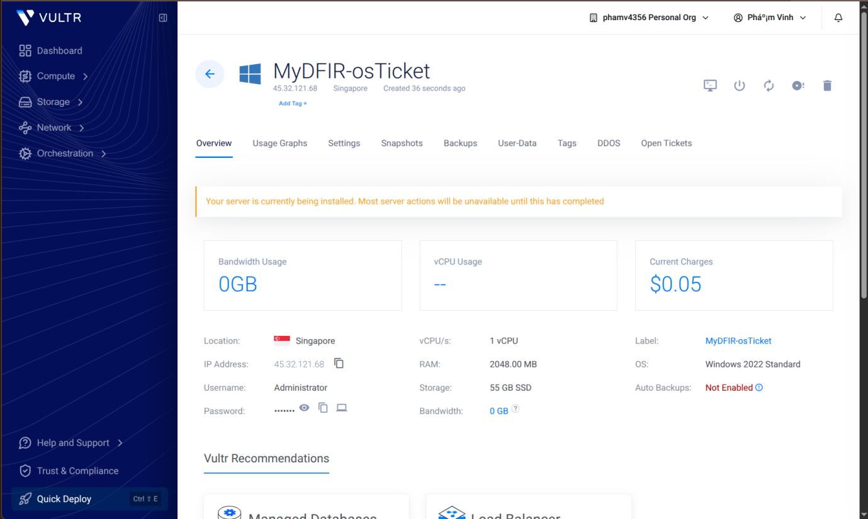
Figure 1: Create a virtual machine for osTicket installation

I set up a web server, database, and other required components to host the osTicket System. I’m using XAMPP to configure the environment quickly and easily.
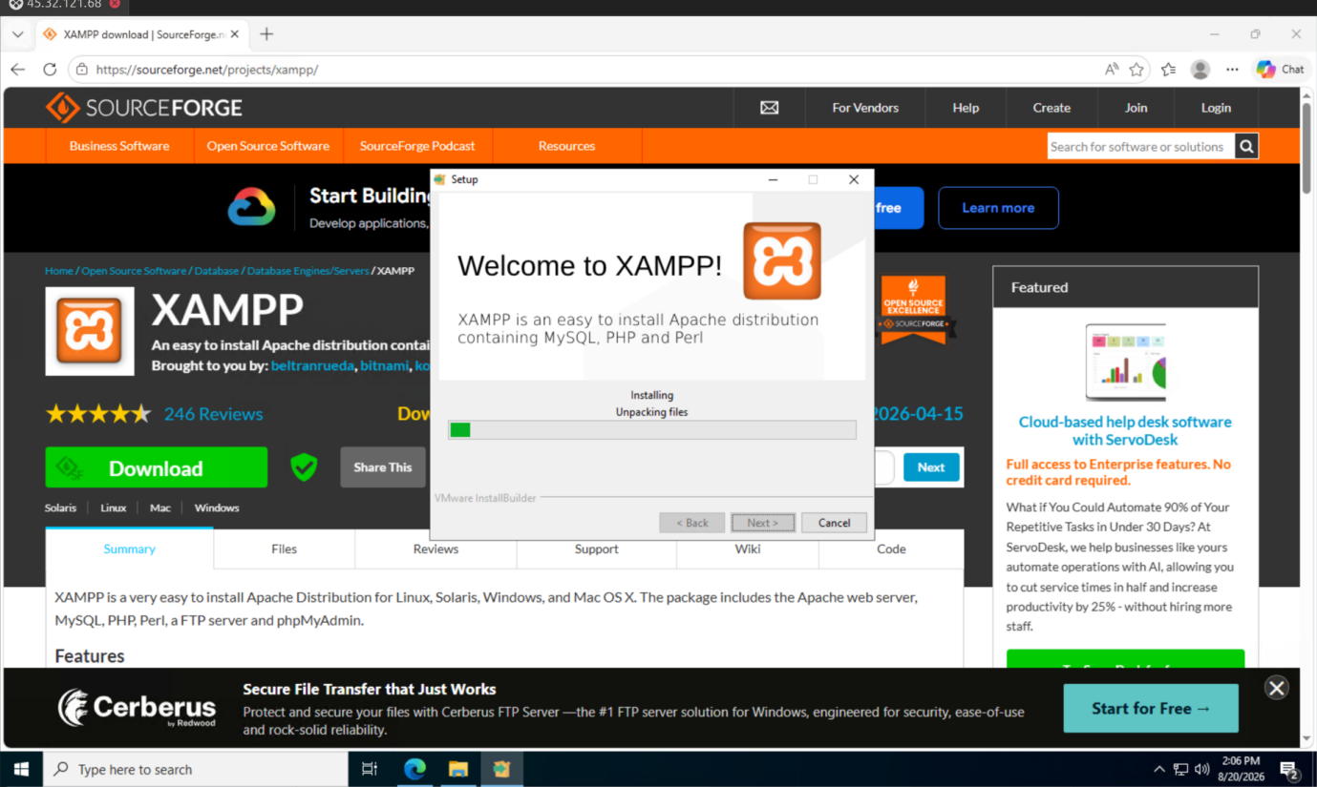
Figure 2: XAMPP installation

After the installation is complete, I will edit a few configuration files:
- File properties:
Scroll down to the Apache section and change apache_domainname value to the IP address associated with the Apache web server. In this case, it is the server’s public IP address (45.32.121.68).
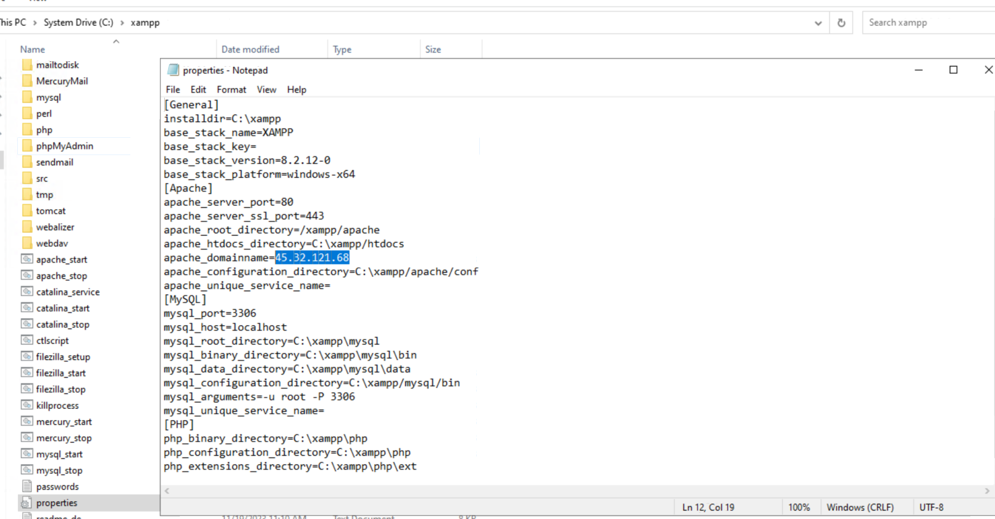
Figure 3: change apache_domainame
- File config.inc:
Change the host value to the IP address associated with the MySQL server. Similar to Apache above configuration, change it to the Windows server’s IP address:
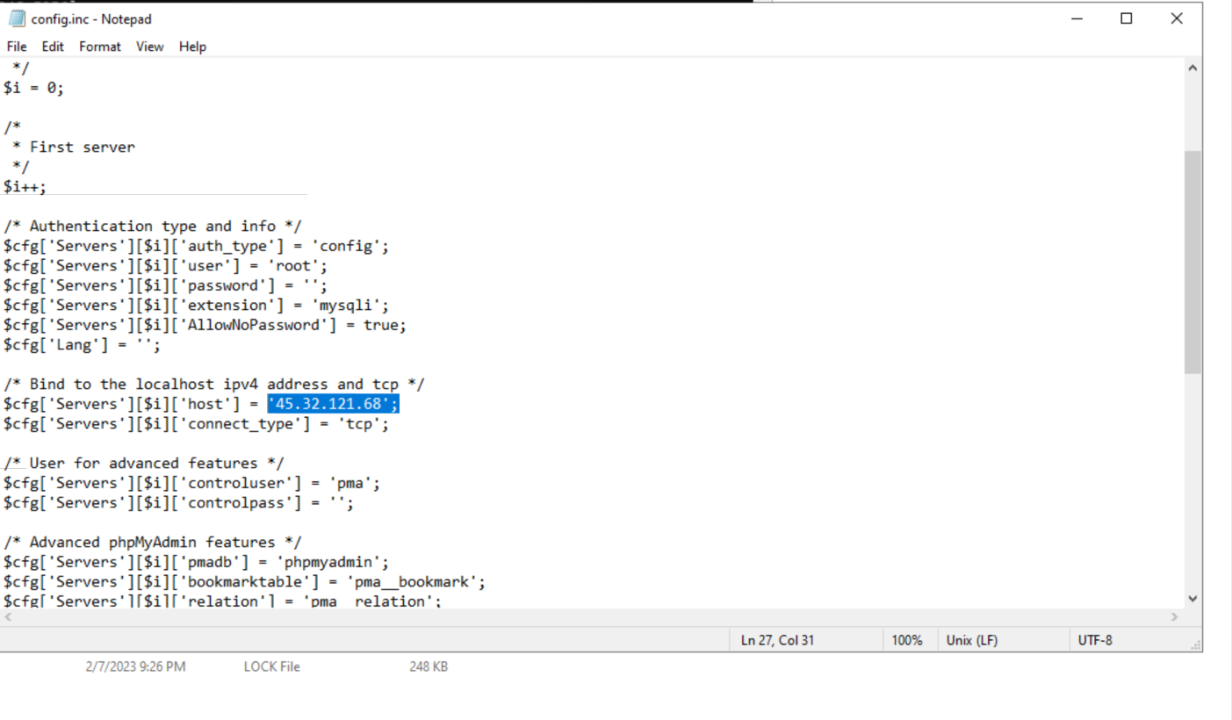
Figure 4: Change host ip in MySQL configuration file
- Edit Inbound rules:
Go to Windows Firewall and add an inbound rule to allow incoming traffic to port 80 and 443:
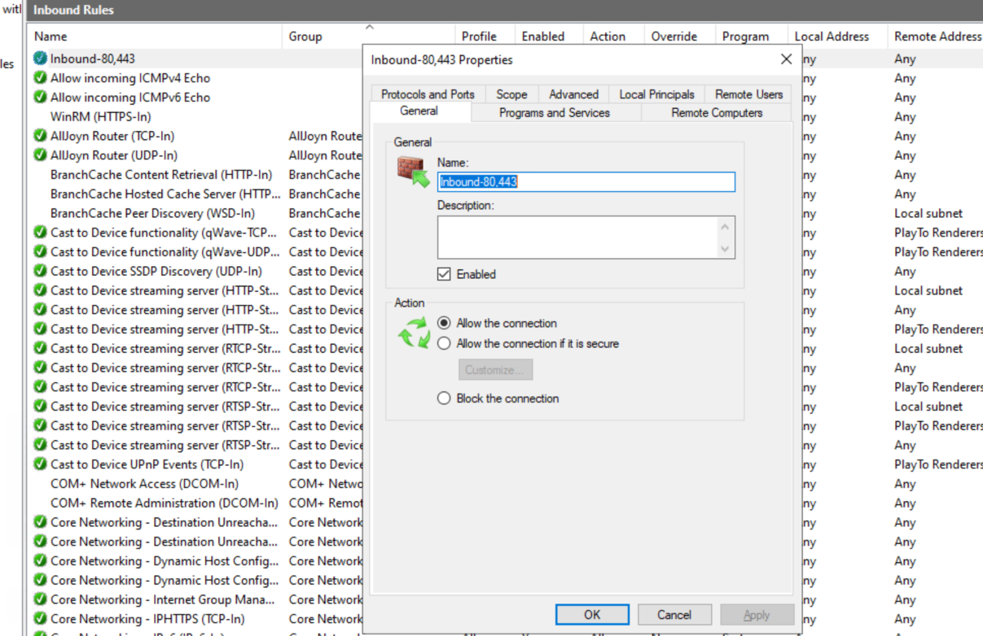
Figure 5: Add an inbound rule for allowing port 80 and 443
- Restart Apache and MySQL
Restart Apache and MySQL service, then access to localhost.The XAMPP dashboard page should appear:
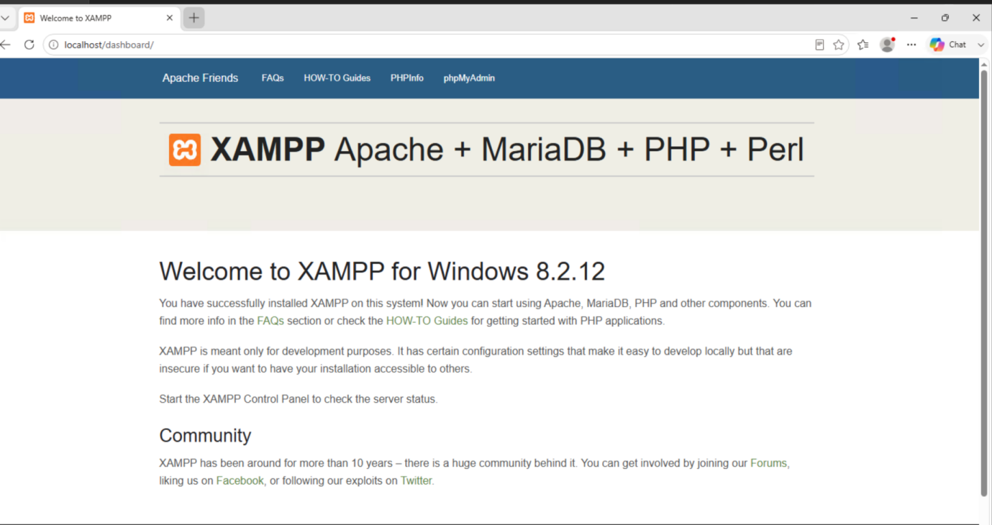
Figure 6: XAMPP dashboard
Access the URL http://45.32.121.68/osticket. It will redirect us to osTicket installation page:
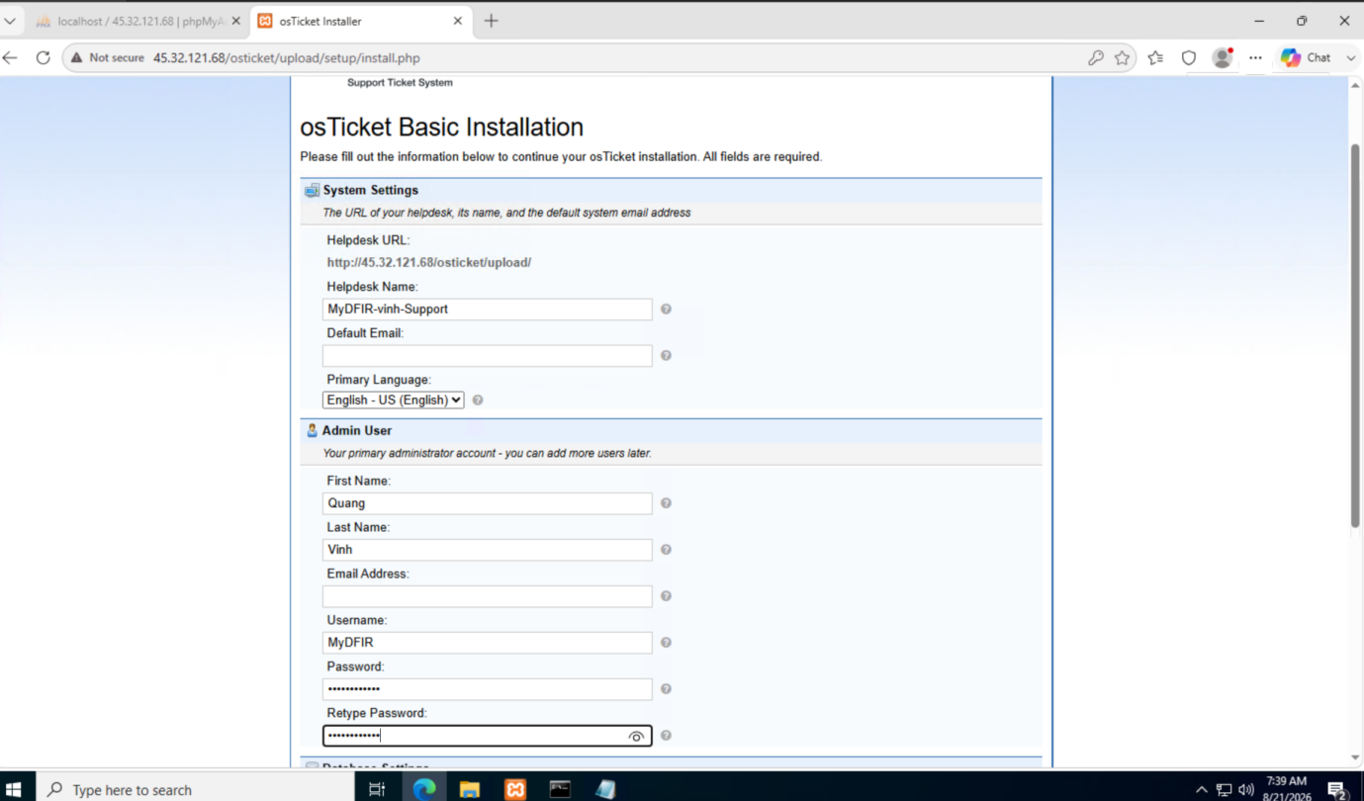
Figure 7: osTicket installation page

Fill some required information:
- Username: MyDFIR
- Password: Quangvinh243
- Email Address of Admin user: phamv4356@gmail.com
- Specify MySQL password, username, database name
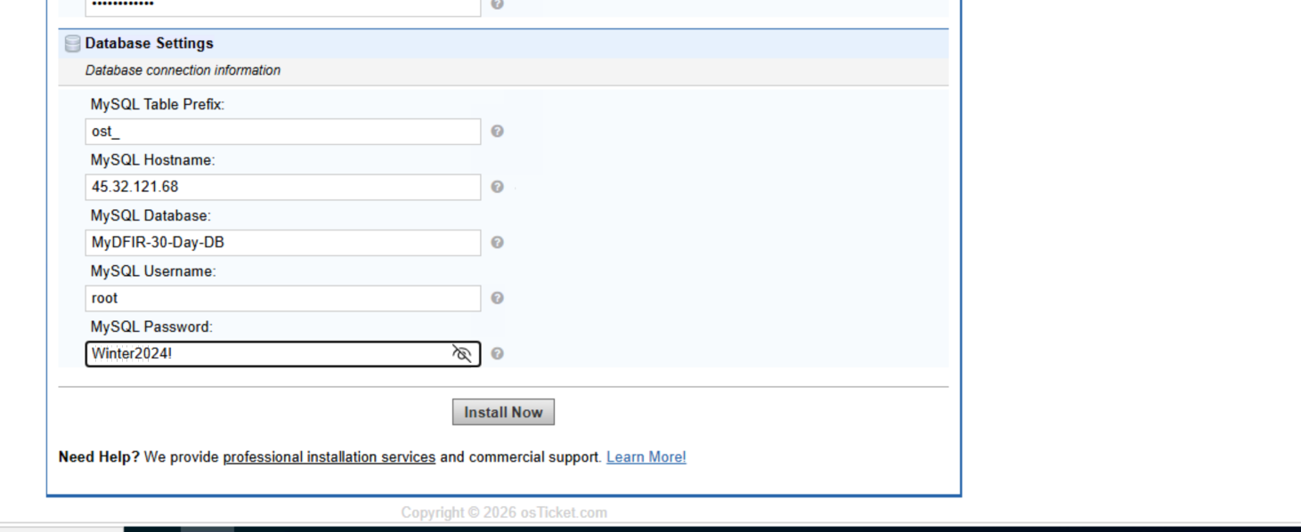
Figure 8: Specify Database settings

⚠️ Note: You have to create a separate database name “MyDFIR-30-Day-DB” as Figure 8. Otherwise, you will encounter the following error during osTicket setup (because this will not create automatically for you):
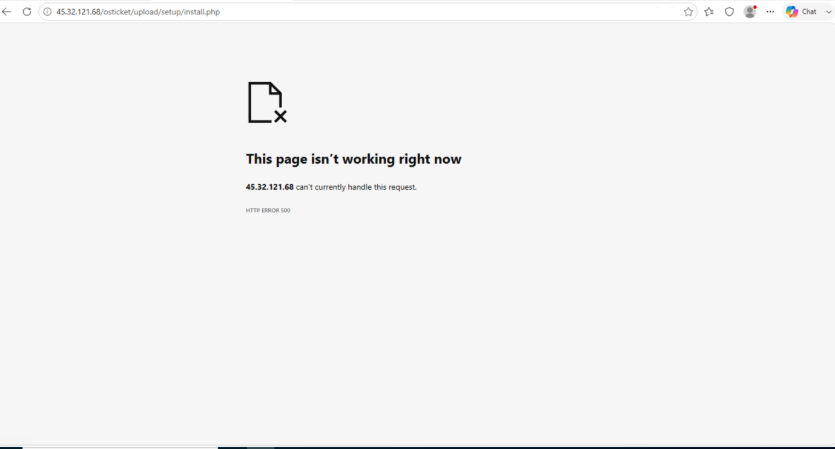
Figure 9: failed osTicket installation

After the database creation is complete, set some user root permissions on that database:
💡 You can create and set permission on that database using command line
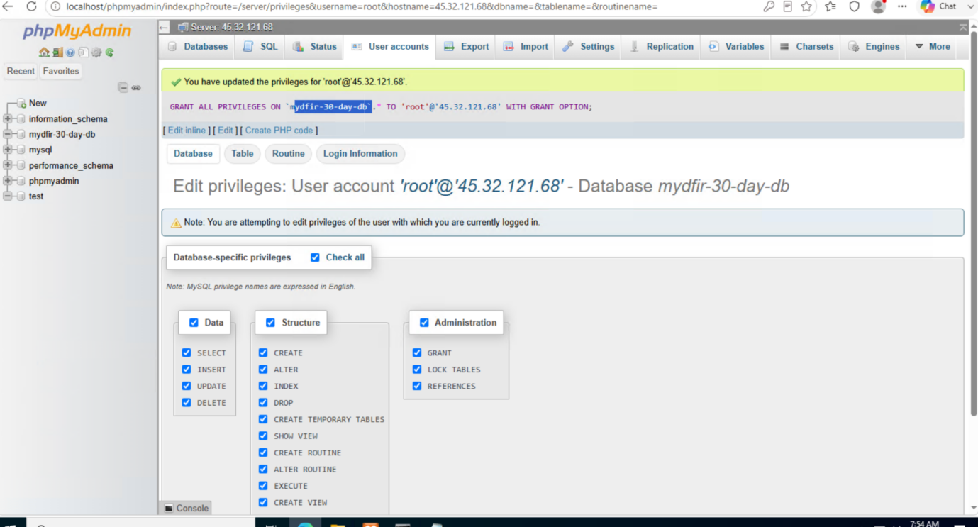
Figure 10: Specify permissions on root@45.32.121.68
Now, if I follow instructions above, I should see the osTicket Congratulations page:
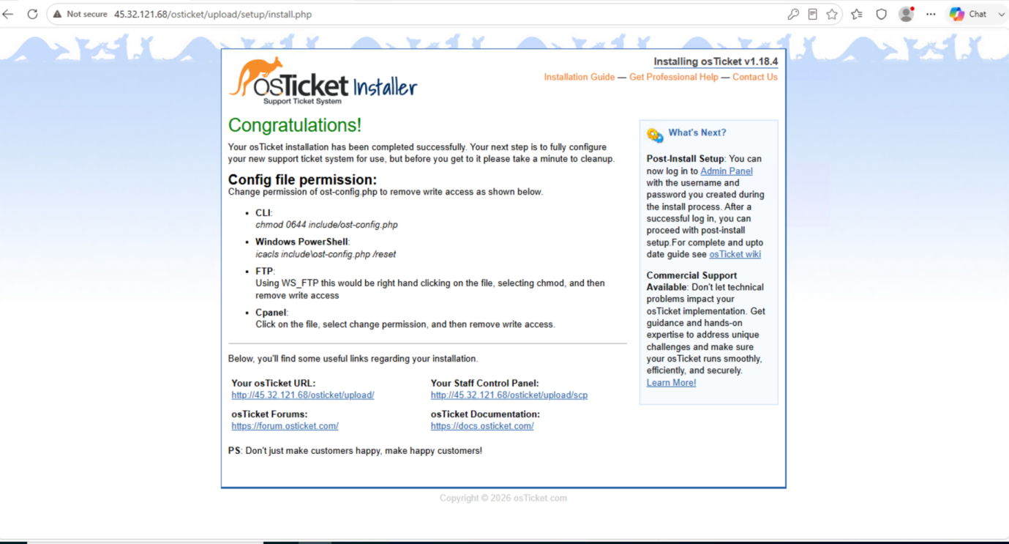
Figure 11: Set up osTicket successfully
Below, you'll find some useful links regarding your installation.
- Your osTicket URL:  http://45.32.121.68/osticket/upload/ | - Your Staff Control Panel:  http://45.32.121.68/osticket/upload/scp
- osTicket Forums:  https://forum.osticket.com/ | - osTicket Documentation:  https://docs.osticket.com/

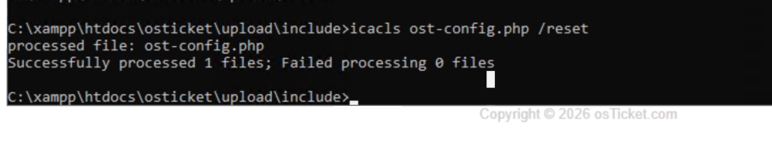
Login vào trang staff (trang số (2)) với username là “MyDFIR” và mật khẩu tương ứng đã setup phía trên.
Bonus: Distinguish between Agents vs. Users in osTicket
- Users open support tickets to ask for help.
- Agents answer those tickets and provide support.
- They are kept as separate accounts in the system

